Full Stack Development with MERN
Project Documentation format
1. Introduction
• Project Title: Book A Doctor – Healthcare Appointment Booking System
• Team Members: K.Shirisha
Frontend Developer, Backend Developer, Database Management, Testing & Documentation

2. Project Overview
• Purpose:The Book A Doctor application is a healthcare appointment booking system developed using the MERN Stack. It allows patients to register, log in securely, browse available doctors, book appointments, and manage their appointments. Doctors can access their dashboard, view appointments, and manage their profile.
Features:
User Registration
User Login
JWT Authentication
Patient Dashboard
Doctor Dashboard
Doctor Listing
Book Appointment
My Appointments
Medical Reports Page
Doctor Profile
Logout
MongoDB Database Integration

3. Architecture
• Frontend:
Technology Used
- React.js
- React Router DOM
- Axios
- CSS
Modules
- Home Page
- Login
- Register
- Doctors
- Appointment
- Patient Dashboard
- Doctor Dashboard
- Reports
- Doctor Profile

• Backend:
Technology Used
- Node.js
- Express.js
Backend Modules
- Authentication
- Doctor Management
- Appointment Management
- Report Management
- JWT Middleware

• Database:
Database Used
MongoDB Atlas
Collections
- Users
- Doctors
- Appointments
- Reports
Relationships
- One Patient → Many Appointments
- One Doctor → Many Appointments

4. Setup Instructions
• Prerequisites:
Install
- Node.js
- MongoDB Atlas Account
- Git
- VS Code
- Postman
• Installation:
git clone https://github.com/kshirisha072-art/BOOK-A-DOCTOR.git

Frontend
cd frontend
npm install
npm start

Backend
cd backend
npm install
npm run dev

Create .env
MONGO_URI=Your_MongoDB_Atlas_Connection_String

JWT_SECRET=Your_JWT_Secret

5. Folder Structure
• Client:
── frontend
│ ├── public
│ ├── src
│ │ ├── assets
│ │ ├── components
│ │ ├── pages
│ │ ├── services
│ │ ├── App.js
│ │ └── index.js
│ └── package.json
• Server:
│
├── backend
│ ├── config
│ ├── controllers
│ ├── middleware
│ ├── models
│ ├── routes
│ ├── uploads
│ ├── utils
│ ├── validations
│ ├── server.js
│ └── package.json
6. Running the Application
o Frontend: cd frontend
npm start.
o Backend:
cd backend

npm run dev

7. API Documentation
Authentication
Register POST /api/auth/register
Login POST /api/auth/login
Doctors
Get All Doctors GET /api/doctors
Add Doctor POST /api/doctors
Appointments
Book Appointment POST /api/appointments
Get My Appointments GET /api/appointments

. 8. Authentication
The application uses JWT (JSON Web Token) authentication.
Workflow
- User registers
- Password is encrypted using bcrypt
- User logs in
- JWT Token is generated
- Token is stored in Local Storage
- Protected APIs validate the token before allowing access

9. User Interface

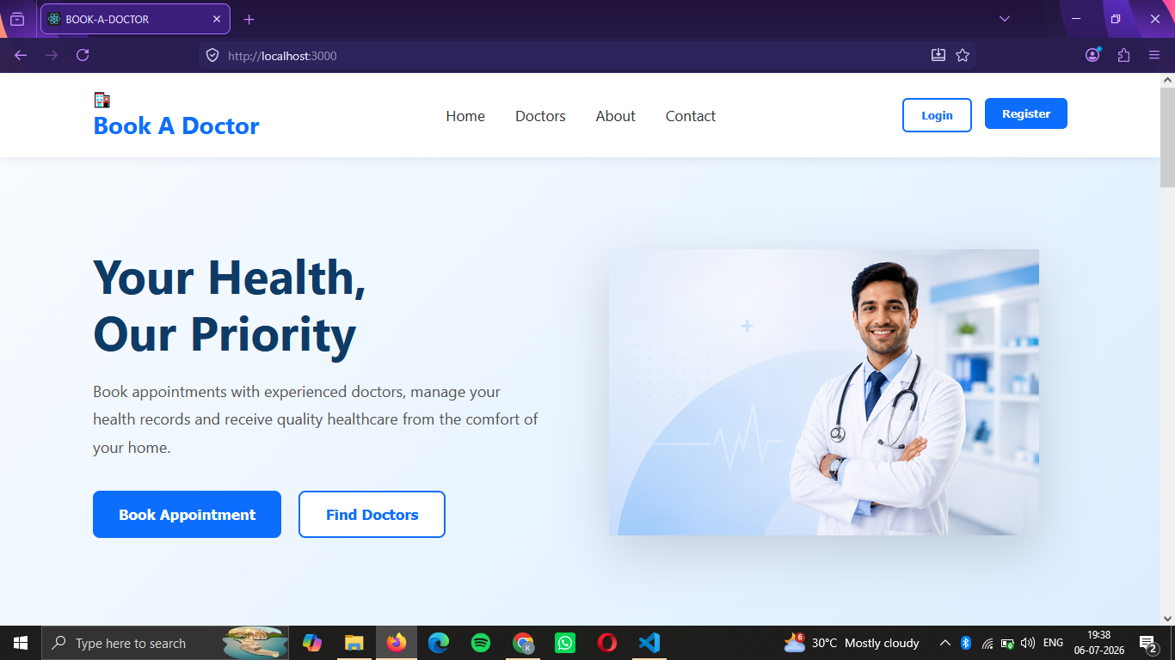
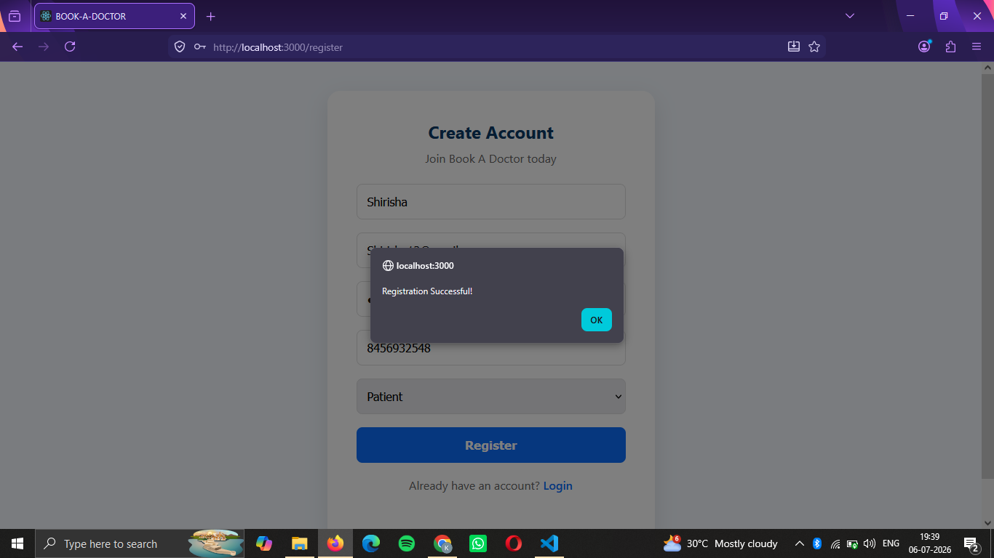
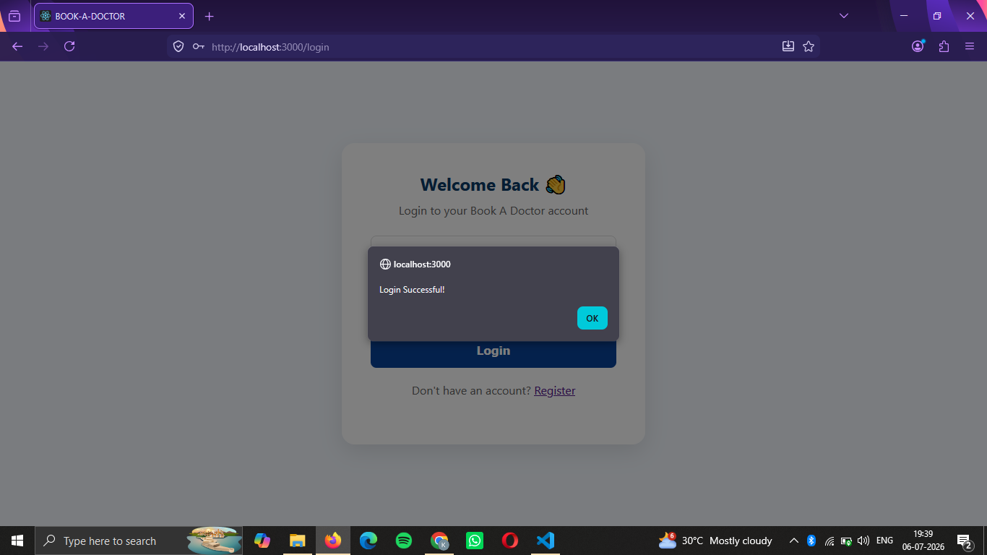
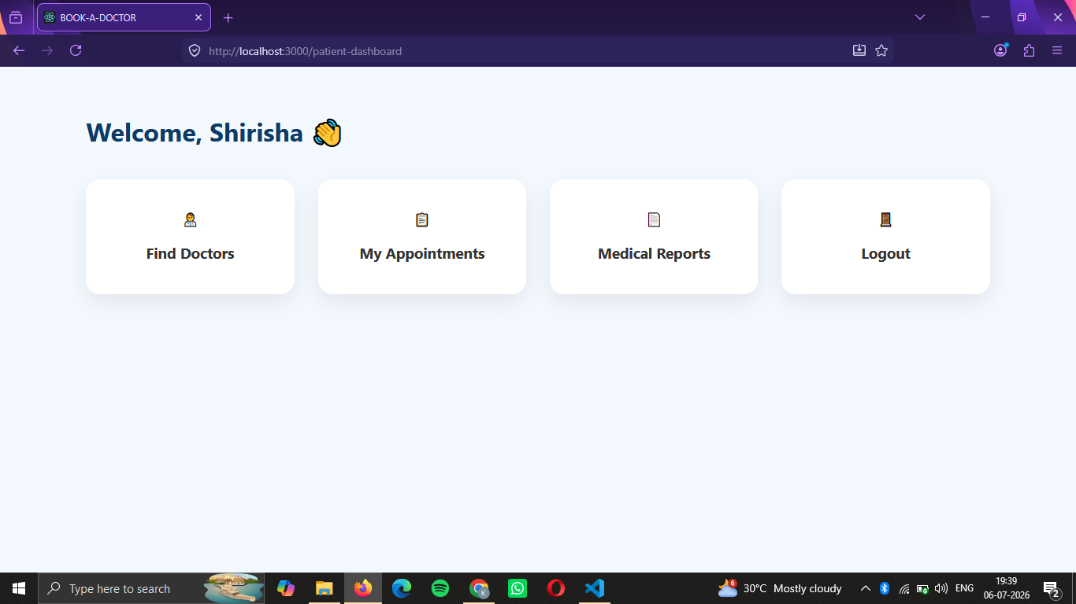
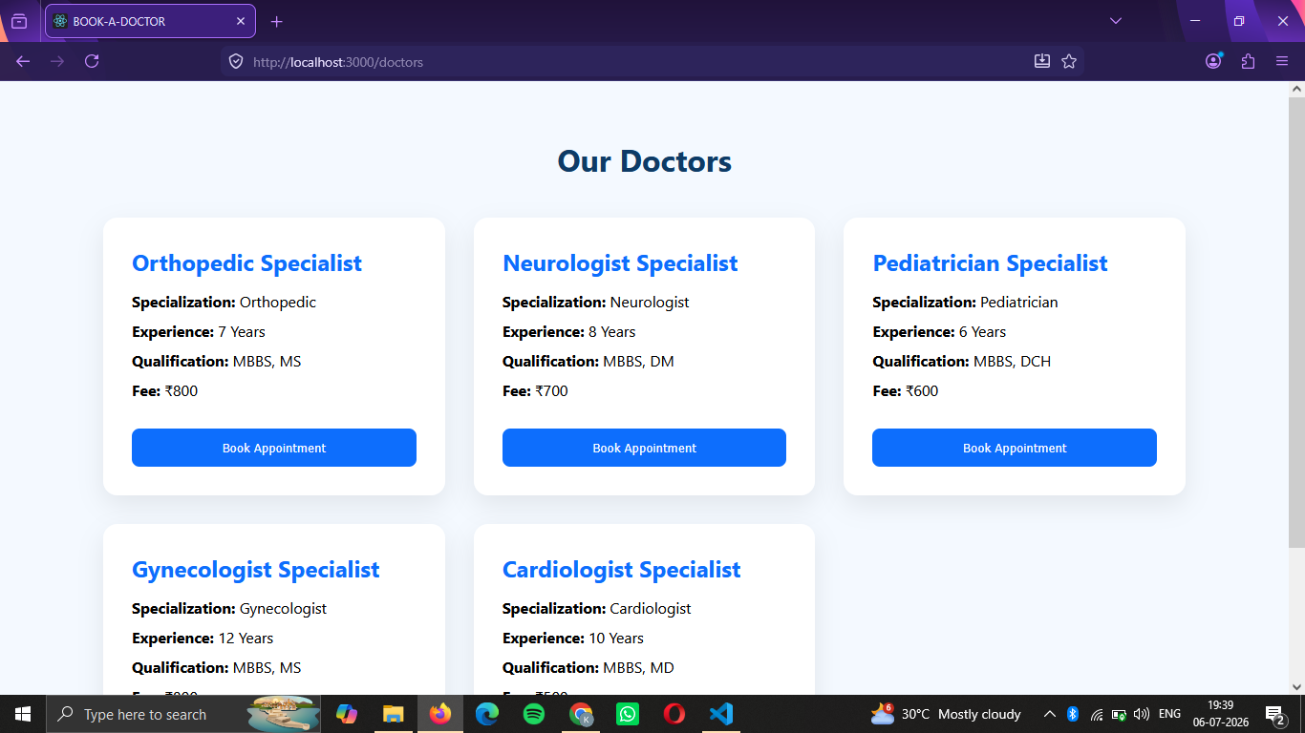
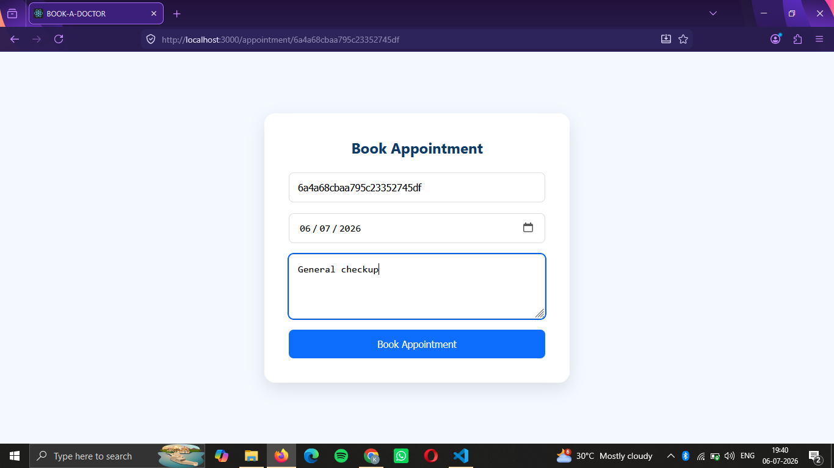
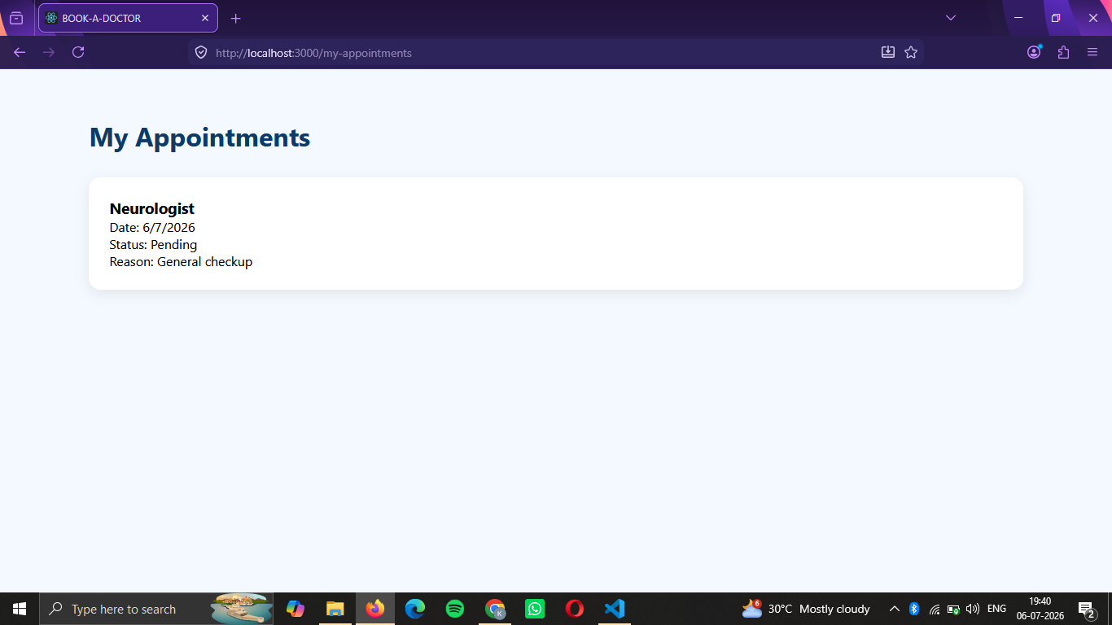

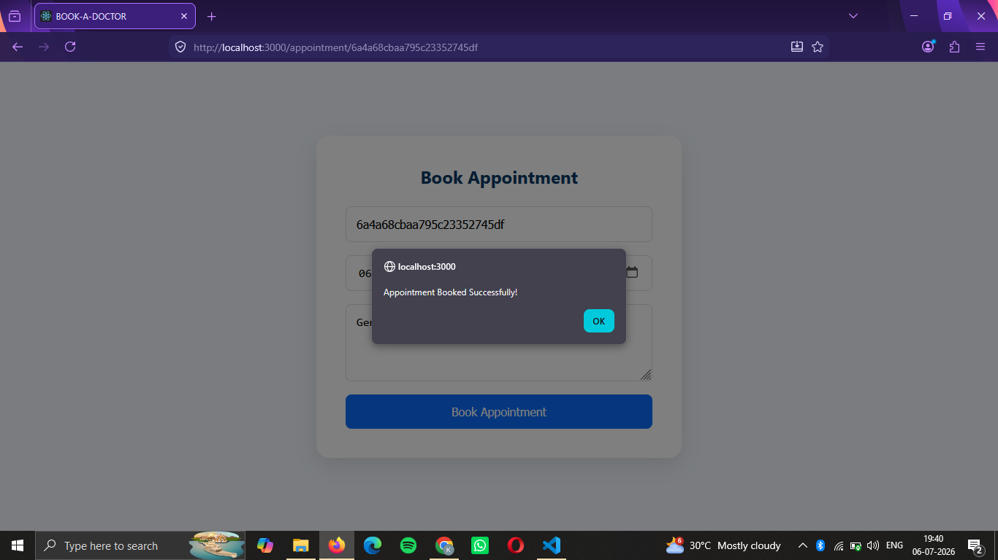
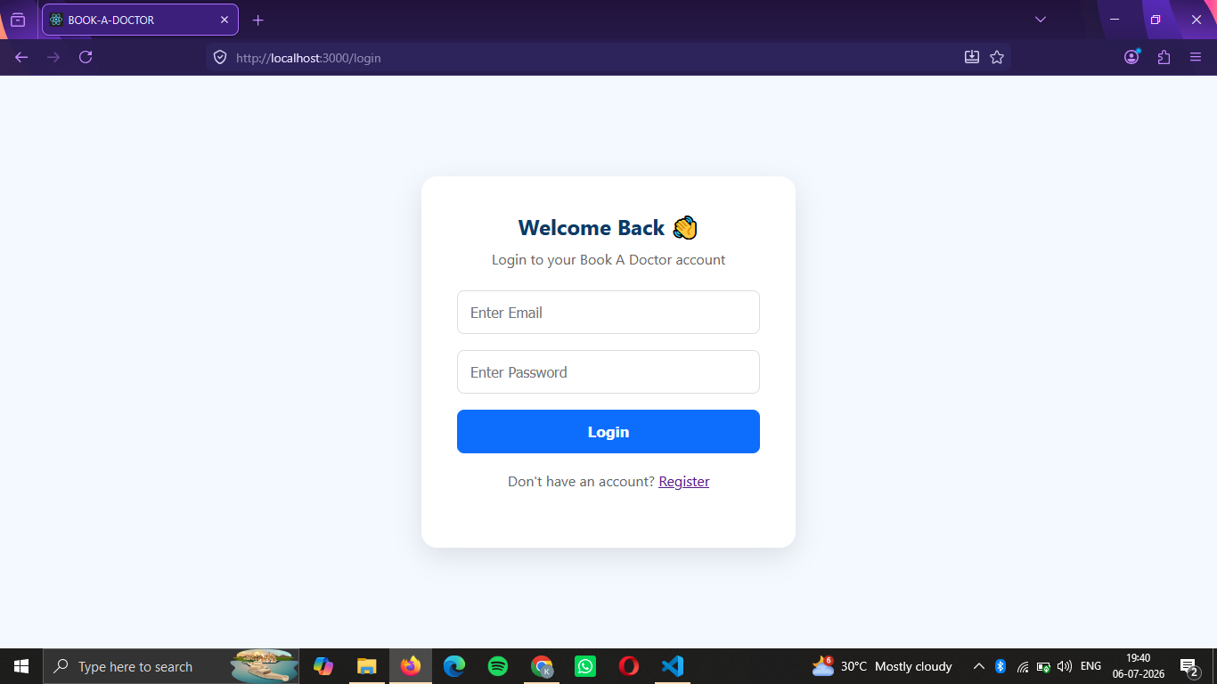

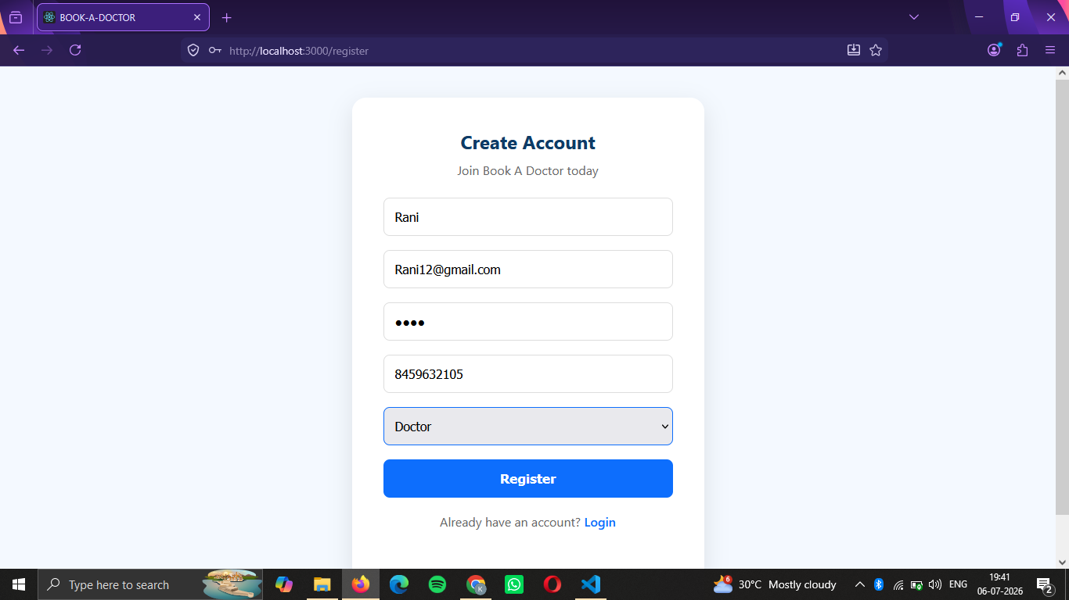
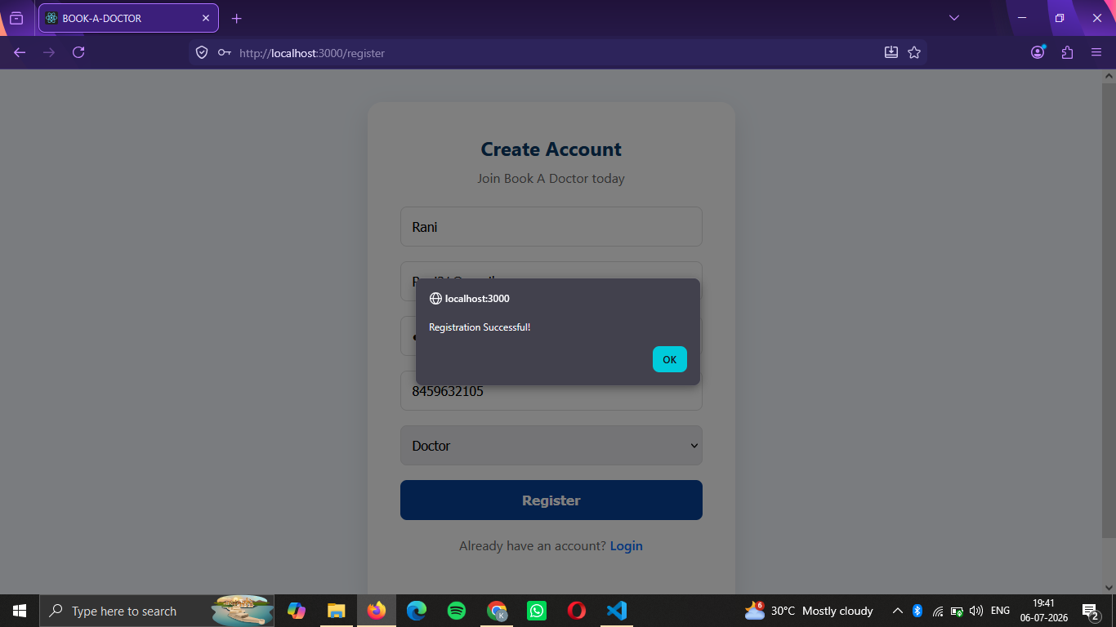
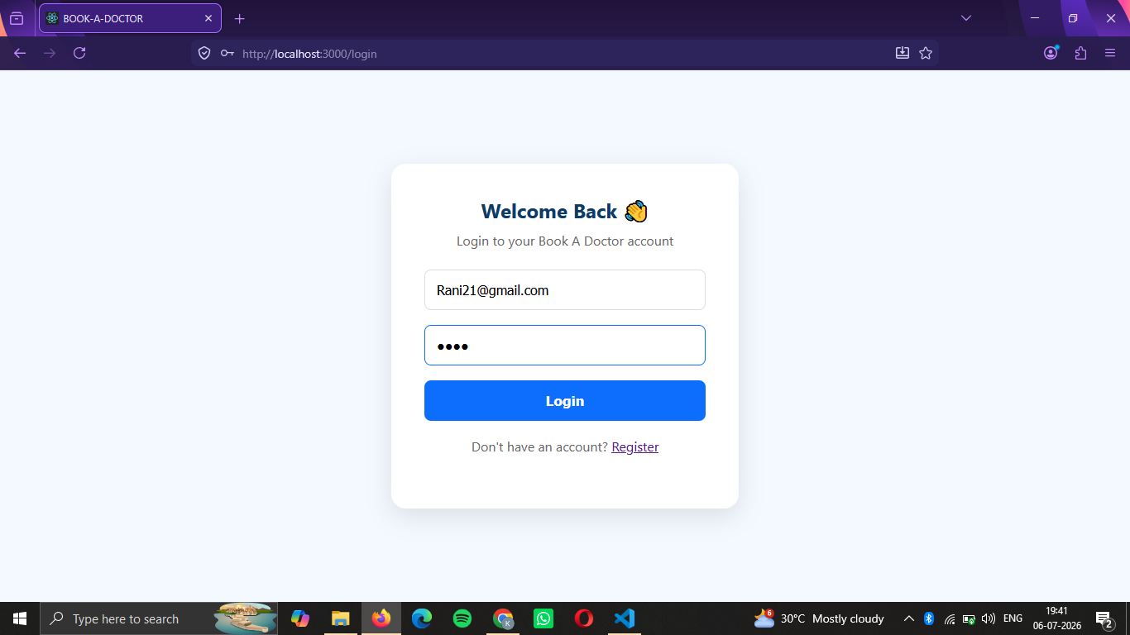
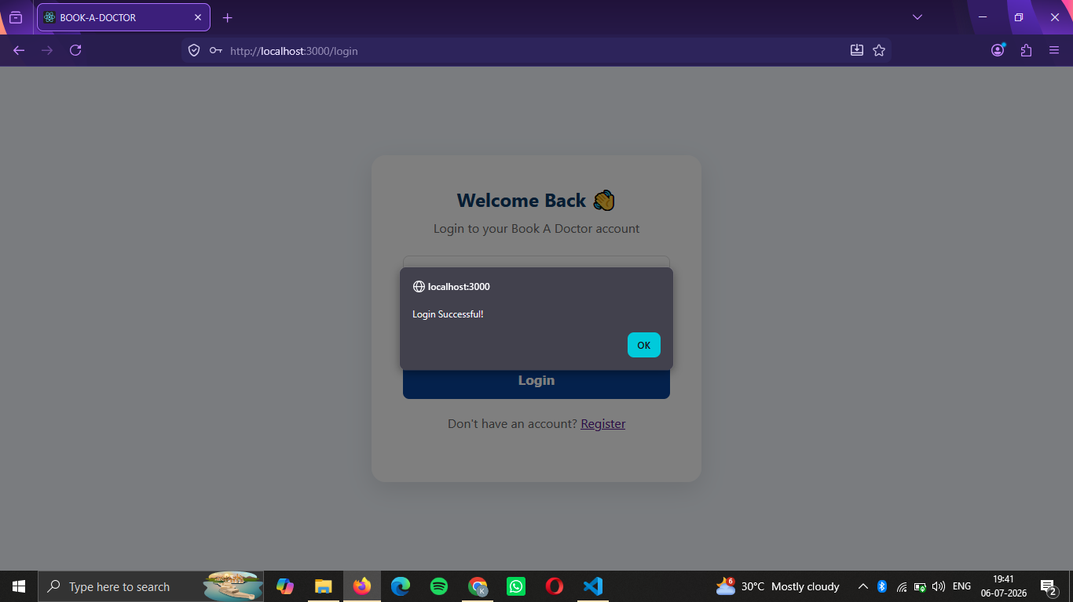
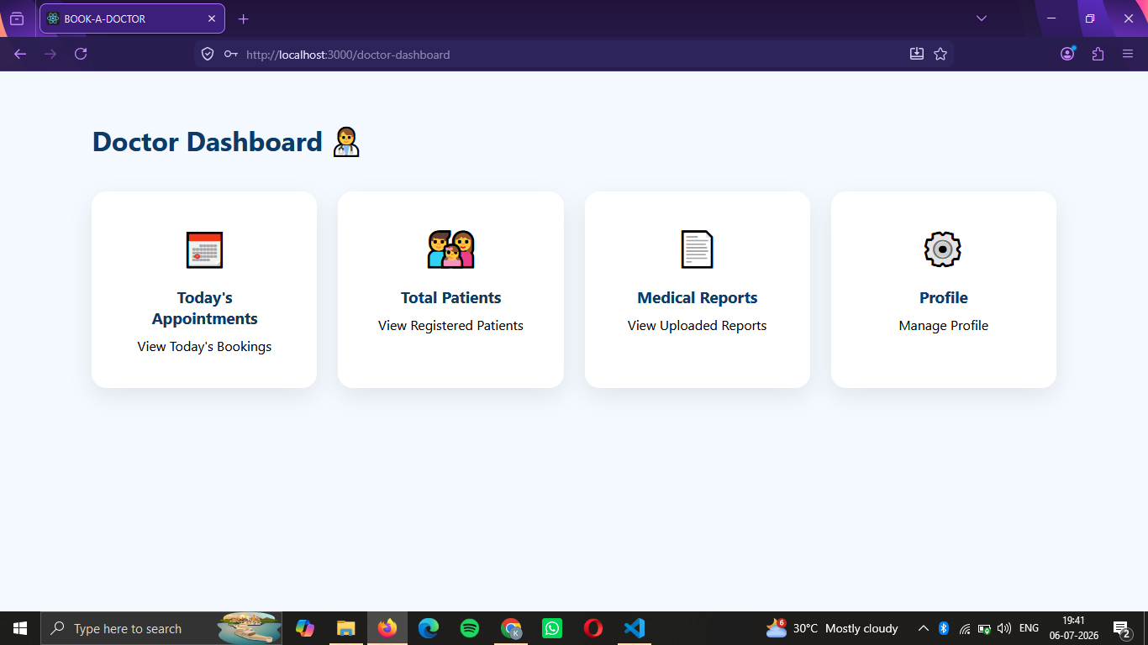

10. Testing
Testing Tools
- Postman
- MongoDB Atlas
- Chrome Browser
Test Cases
- User Registration
- User Login
- JWT Authentication
- Doctor Fetching
- Appointment Booking
- Dashboard Navigation
- Logout

11. Screenshots or Demo
Demo link : https://drive.google.com/file/d/1Pc9aOYXTN4vfHQ_LJYtTggV6qL_w4TVd/view?usp=sharing











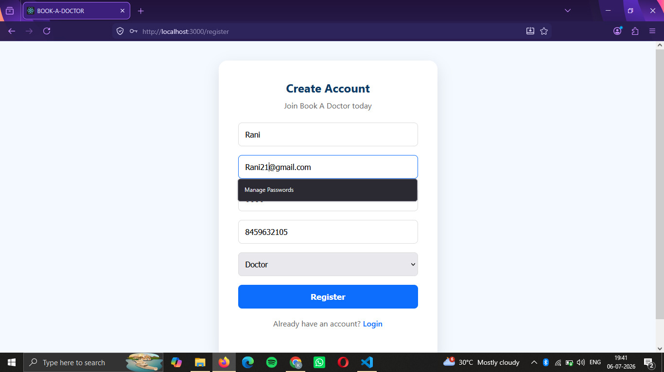





12. Known Issues
- Doctor Dashboard currently contains basic placeholder pages for appointments, patients, and reports.
- Medical Reports feature is currently informational and does not support file uploads.
- Appointment status updates (Confirm/Cancel) are not implemented.
13. Future Enhancements
- Online Payment Gateway Integration
- Doctor Availability Calendar
- Email & SMS Appointment Notifications
- Online Video Consultation
- Prescription Upload & Download
- Admin Dashboard
- Search and Filter Doctors by Specialty
- Patient Feedback and Ratings
- Appointment Cancellation & Rescheduling
- Responsive Mobile Application

